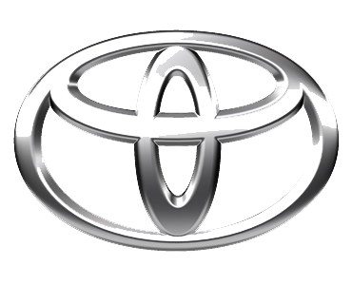
undefined
TOYOTA MOTOR CORPORATION
I. TOYOTA-CHO TOYOTA. AICHI, 471—8571(HEAD OFFICE)
or 471 8572 (Research 5 Development Group) THAILAND
TEL: +81-565-28-212

GSO Conformity Certificate CCR No. 587161
Motor Vehicles
Manufacturer: TOYOTA MOTOR CORPORATION
Country of Origin: JAPAN, Country of Production: JAPAN
To: GCC Standardization Organization (GSO)
We hereby certify that the vehicles manufactured by TOYOTA MOTOR CORPORATION
* Type: TOYOTA COASTER 4.2L Diesel Bus RWD 23 Seats
* VlN number: JTGCKCB8*S*******
* Model Year: 2025 * Produced in and after: Month 09 Year 2025
* Category: Bus
Will satisfy the G50 Technical Regulations Nos: 34:20o7, 3s:2007, 36:2005, 37:2012, 38:200s, 392005, 40:2011,42:2015, 48:1984, 51:20o7, 52:2007, 53.2007, 9611988. 9721988, 9811988, 9921988,13522007, 13622007. 29021994. 4119:1994,42o:1994,421:2005,422:200s.1040:20001041:2000,1042:2000,1053:2000,1503:2010,1598:2002,1624:2002,1677:2003,1708:2o0s,1780:2010,1781:2006,1782:2008,1783:2006,1784:2o0e.Gsolso1585:2008,GSO lSO 3537:2008, GSO 150 3538:1997, G50 ECE13H:2012,GSO ECE13H-1:2012,GSO ECE13H-2:2012,GSO ECE 13H-3:2012, GSO ECE13H-4:20l2, GSO ECE13H-S:2012,GSO ECE 13H-6:2012 and the standards in the country of origin accepted by GSO in the case that no GSO technical regulations and standards are available.
All the essential technical data are as follows:
1. Weights
a. Maximum Vehicle Weight: 5670 kg b. Curb: 3515 kg
c. Maximum Axle Weight: Front: 2400 kg Rear: 3270 kg
2. Dimensions
a. Length: 6990 mm b. Width: 2080 mm
c. Height: 2635 mm d. Wheelbase (Fl R1) 3935 mm e. Track: Front: 1690 mm Rear: 1690 mm
3. Type of chassis and body: Body-on-frame
4. Number of Passengers: 23(Including the Driver)
5.Engine: Diesel a. Cylinders: 6 b. Displacement: 4164cc c. Air intake: Naturally Aspirated
d. Net Engine Power: 96 kW at 3800 rpm Pollutant Limit comply with Euro 4.
6. Transmission: Manual

7. Brakes a. Service Brakes: Hydraulic b. Emergency Brakes: Combined with the service brake
8. Fuel Economy a. Motor Vehicle Class: Heavy Truck b. FE (CAFE) Combined: 09.5.7 km/L - Poor
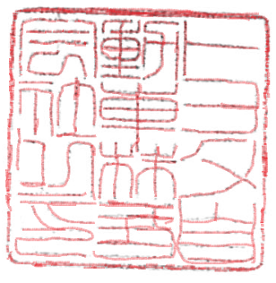
9. Any other information or local standards to be compiled: Also comply with the National regulations for member countries mentioned in the Annex of the list of Technical Regulations for MV 2025 MY-D5, when exporting to those countries. for member countries mentioned in the Annex of the list of Technical Regulations for MV 2025MY-D3, when exporting to those countries. for member countries mentioned in the Annex of the list of Technical Regulations for MV 2025 MY-D3, when exporting to those countries.
Keiko Yanagi
17 SEP 20252025
general Manager Regulation &Certiﬁcation Division

